Logo%20Main%20200

**Boston University**

**Electrical & Computer Engineering**

**EC464 Capstone Senior Design Project**



User's Manual

Student-defined Project

by

Team 4

OverEar

**Team Members**

Guillermo Ao raoliang[@bu.edu](mailto:email1@bu.edu)

Hannah Gold htgold[@bu.edu](mailto:email1@bu.edu)

Benjamin Li [liben002@bu.edu](mailto:liben002@bu.edu)

Jonathan Ngo jonngo@bu.edu

Submitted: April 18th 2022

#### Table of Contents

**Table of Contents** **1**

**Executive Summary** **2**

**Introduction** **3**

**System Overview and Installation** **4**

Overview Block Diagram **4**

Physical Description **4**

Installation, Setup, and Support **5**

**Operation of the Project** **6**

Operating Mode 1: Normal Operation **6**

Operating Mode 2: Abnormal Operations **6**

Safety Issues **7**

**Technical Background** **9**

**Relevant Engineering Standards** **10**

**Cost Breakdown** **11**

**Appendices** **12**

Appendix A - Specifications **12**

Appendix B – Attenuation Characteristics **12**

Appendix C – Team Information **12**

# 

# 

# 

# 

# 

# Executive Summary

OverEar is a device that aims to solve the Cocktail Party problem, a phenomenon where certain people, due to a hearing or neurological impairment, are not able to focus on someone talking to them in a noisy gathering —a cocktail party, for example. To fulfill our obligations as societal engineers, we have created an embedded device that will perform sound segregation in real-time, allowing users to focus their concentration on the sound oriented in front of them. Our device processes sound input from two microphones and runs the data through a custom sound-localization algorithm. It will then be relayed to the user in the form of non-intrusive in-ear plugs depending on the user’s preference. Our innovative project combines a two-microphone approach with real-time audio processing.

# Introduction

The Cocktail Party effect is a phenomenon where one is able to focus their attention on a stimulus while filtering out other distracting sounds, especially in the context of conversing with someone in a room filled with chatter. Those who cannot do this well experience the Cocktail Party problem. Moreover, even with the introduction of more advanced hearing aids, the Cocktail Party problem remains. Many hearing aids do not perform sound separation but rather amplify all sounds being received. Those which do perform sound separation utilize an array of directional microphones and turn those on and off to provide the effect of damping background noise; however, it is our understanding that this solution is still suboptimal.

The OverEar team has taken a signal processing approach to sound segregation and aims to limit and localize noise robustly and effectively. Words spoken in a noisy environment will become localized such that the sounds directly in front of the user, in the 0th azimuth, are amplified and other azimuth degrees are quieter in contrast. The device is a portable and real-time solution to the Cocktail Party Problem and uses off-the-shelf parts to create a final prototype. The end device consists of a customized PCB, two MAX4466 Adafruit electret microphones, a lithium polymer battery, a Teensy 3.5 microcontroller, and a Teensy 3.X audio shield.

With this device, those who experience the Cocktail Party Problem will be able to distinguish words spoken to them in noisy environments and feel more at ease with social situations.

# System Overview and Installation

The OverEar device consists of a central processing unit housed in a 3D-printed box casing along with sensory and output components connected via wires. The sensory components are two microphones that provide the input and earbuds to provide output. The device also includes stability clips that can be used to secure the processing unit onto a belt or strap of a bag. The exterior of the casing includes buttons and a knob for user input.

## Overview Block Diagram

The Overear device, shown in Figure 1, has three main features: dual microphone input, the processing unit, and earbud output.

Figure 1. Block Diagram for Overear Device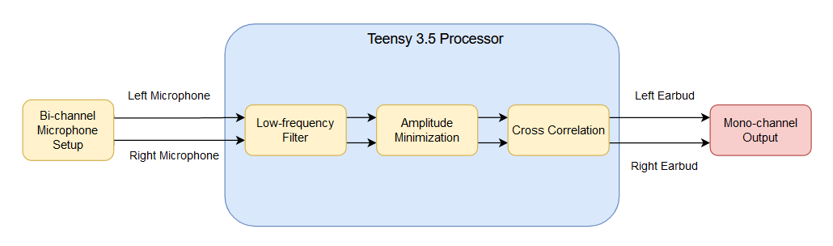

The dual microphones, worn next to each of the user’s ears, provide bi-channel audio input to the device. These microphones are currently the Adafruit MAX4466 electret microphones but can be changed in future iterations of the product. The processing unit is composed of a single Teensy 3.5 microcontroller and its accompanying custom PCB. This processor has been set up to perform sound segregation on the input using a low-frequency filter, amplitude minimization, and cross-correlation amplification. More information on the technical specification of these three modules can be found in Section 4. Finally, the segregated sound is relayed to the user through the left and right earbuds. Both contain the same sound, making the output mono-channel.

## Physical Description

Figures 2, 3, and 4 show the physical components that make up the device. Figure 2 shows the device during intended use. The microphones and earbuds should be attached via the built-in stability clip with one on each ear and worn as normal earbuds. The stability clip of the casing is quite versatile and can easily be clipped onto the user’s pants, bag strap, or hand-held. Figure 3 shows the central processing unit in its casing. Along the casing and labeled on the figure are the On/Off switch, Mute button, and Volume knob for the device. Figure 4 shows the separate, smaller casing to house each of the microphones as well as the stability clips. Please note that the earbuds are not included with the device.

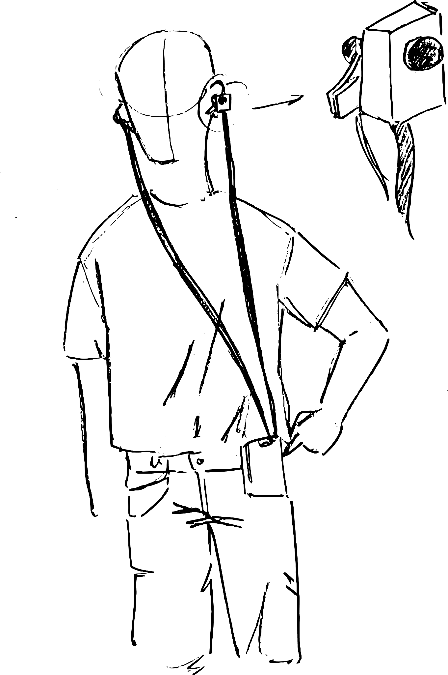 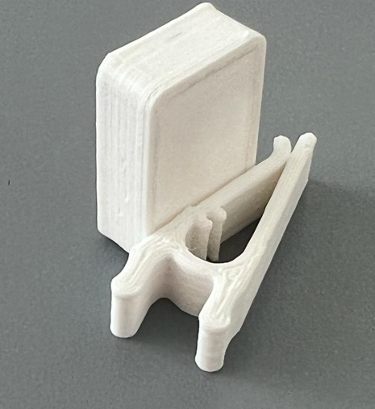

Figure 2. User interface with the OverEar device

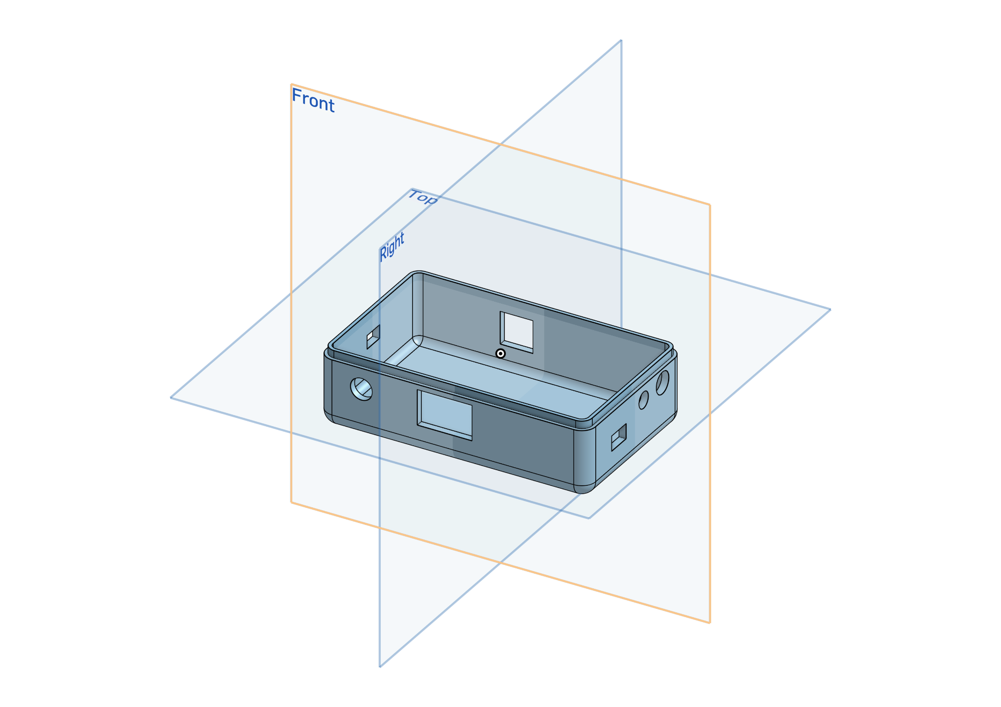

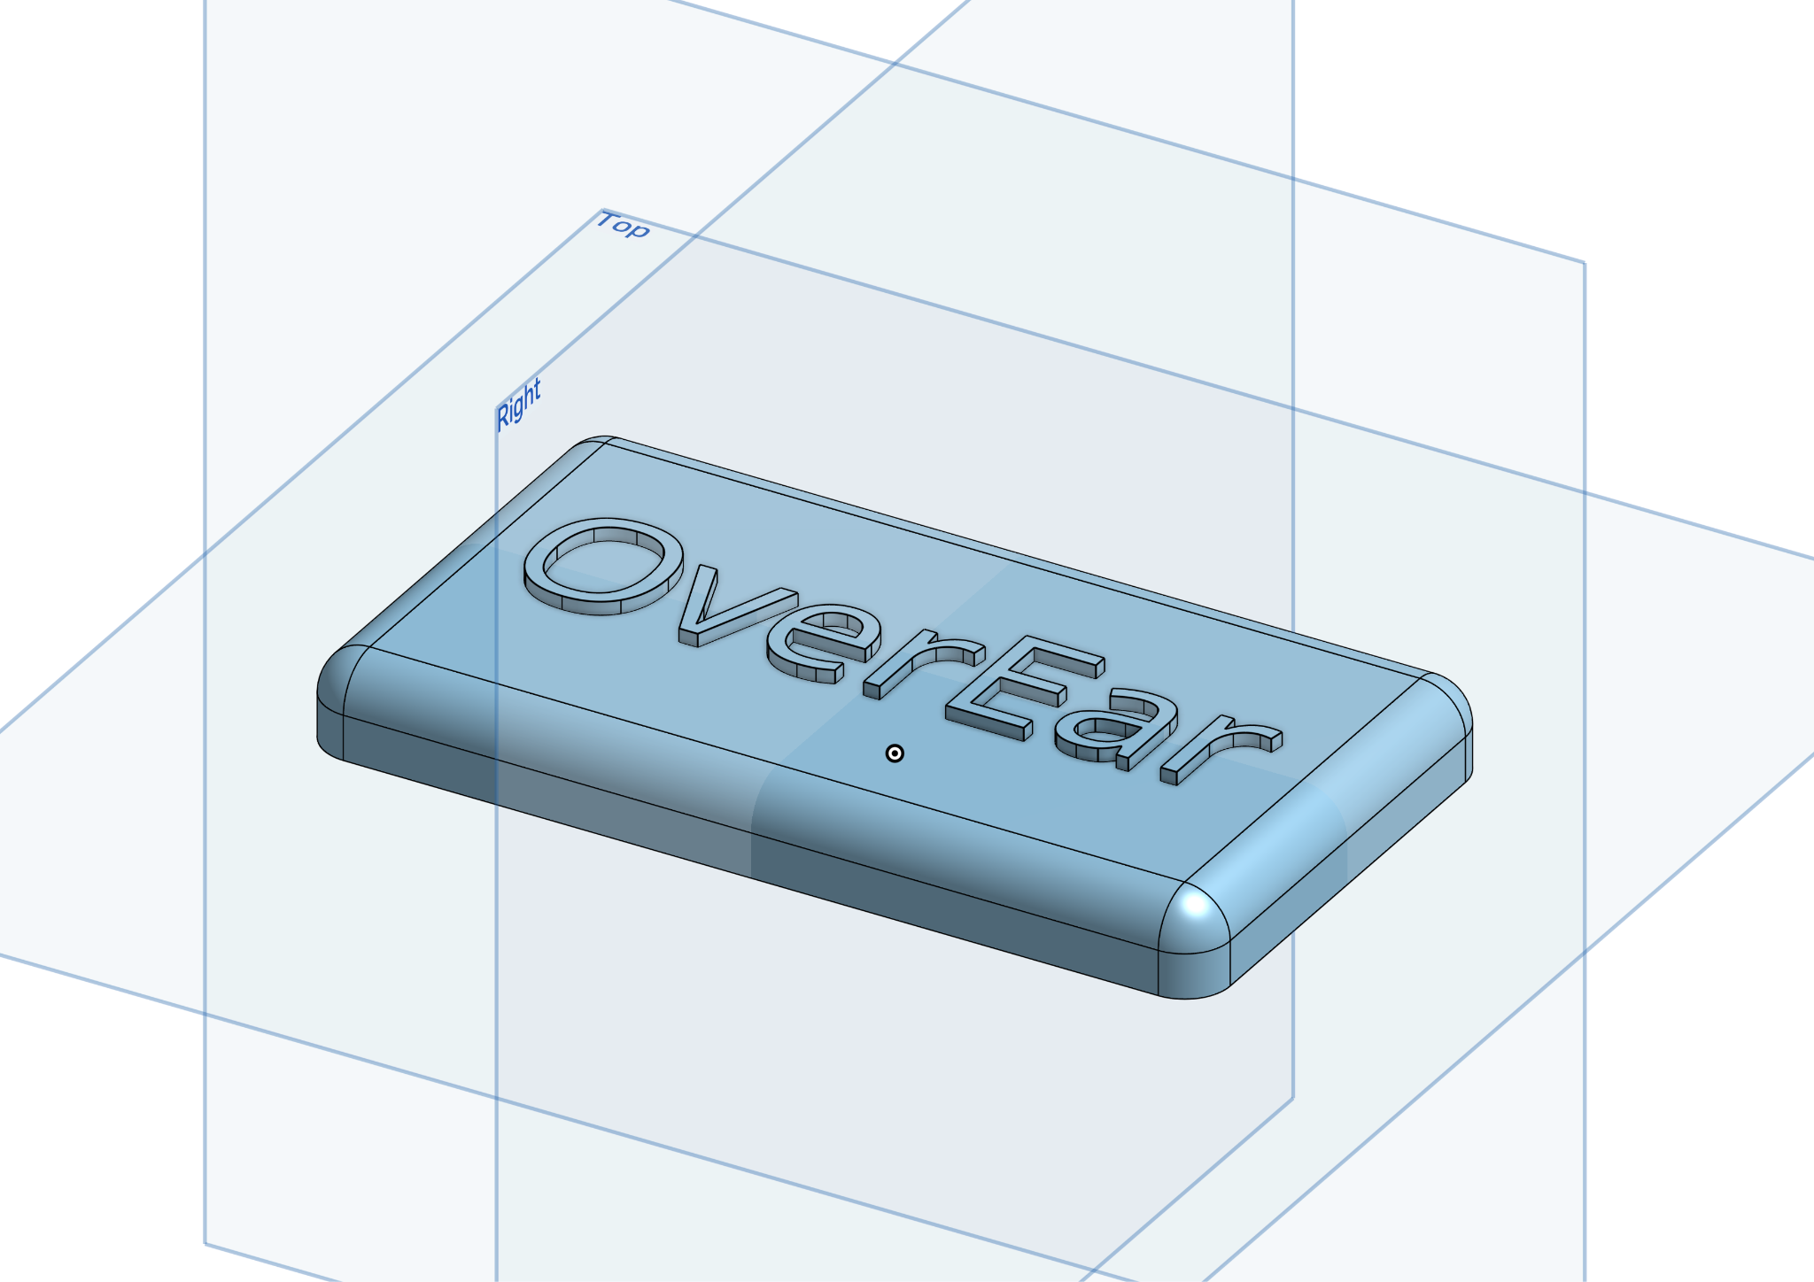



## 

## Installation, Setup, and Support

The device setup is very simple in terms of getting started. Software will be pre-loaded onto the Teensy, and everything with respect to the hardware with the exception of the earbuds will come pre-assembled. The user is expected to provide a pair of earbuds/headphones that have a 3.5mm audio jack. To make sure the device is working properly, do a series of 3 simple tests. First, note if the LED light is ON which means that the device is active. Then speak directly to the left microphone and after that to the right one. Afterwards, speak directly in front of the person wearing the device. The user should note a significant sound reduction when listening from the first 2 tests compared to the final one, meaning that the OverEar device is working properly.

# Operation of the Project

## Operating Mode 1: Normal Operation

Normal operating conditions occur when the device is powered on, the mute button is not pressed, and the volume knob sits at a comfortable level. In this configuration, the user can expect the device to perform the custom sound processing in real time. The sound sources in front of the user will sound distinct and amplified while those from the sides of the user will be attenuated. In normal operation mode, the user can turn the volume knob found on the casing of the device to adjust the gain of the sound output, allowing for louder or softer modes of operation.

The mute button found on the casing of the device can be pressed and held to temporarily pause the operation of the sound segregation algorithm. Until the button is released, the device sits idle. This mode was designed to not only prevent the algorithm from processing the user’s voice, but to also provide a smooth user experience when the user does not wish for the sound processing to occur.

When the battery of the device has run out, the user can simply recharge the battery by plugging in a mini-USB cable to the port on the case.

## Operating Mode 2: Abnormal Operations

Abnormal operation may occur if there is no sound output or if the sound output is incoherent. In the following scenario, there may be two likely causes.

First is when the device runs out of battery. To solve this problem the user simply has to plug in a mini-USB cable to the corresponding port on the processing unit. Initializing the device is just turning it on.

Second, the issue could be due to a microphone malfunction, occurring if the user has already ruled out the case where the device’s ON indication is active, meaning the main electronic components are working, but no sound is coming out of the earbuds. The problem then would likely be with the input devices, which are the microphones. In that case, the OverEar device should be brought to a specialist to test out the microphone directly and fix the problem.

## Safety Issues

Since the OverEar device is electrically driven, it should be used with caution. Even though any electrical components have been covered in the final product, users should not try to tamper with the device, remove wires, or expose the OverEar device to water.

Another safety issue is with the volume of the audio output. Prolonged exposure to loud noises can damage a user’s eardrums, while soft noises can strain the user’s ears. To mitigate this, we have added a volume knob to control the playback volume, but it is up to the user to set it to a reasonable and comfortable level.

According to the Hearing Health Foundation, it is recommended for people to avoid listening to sounds above 70 decibels as seen in Figure 5. Higher than 70 decibels can cause harm over time. Headphones can output up to 100 decibels of sound, but it is recommended that the user use a safe level of 50 to 60 percent of the maximal headphone volume.

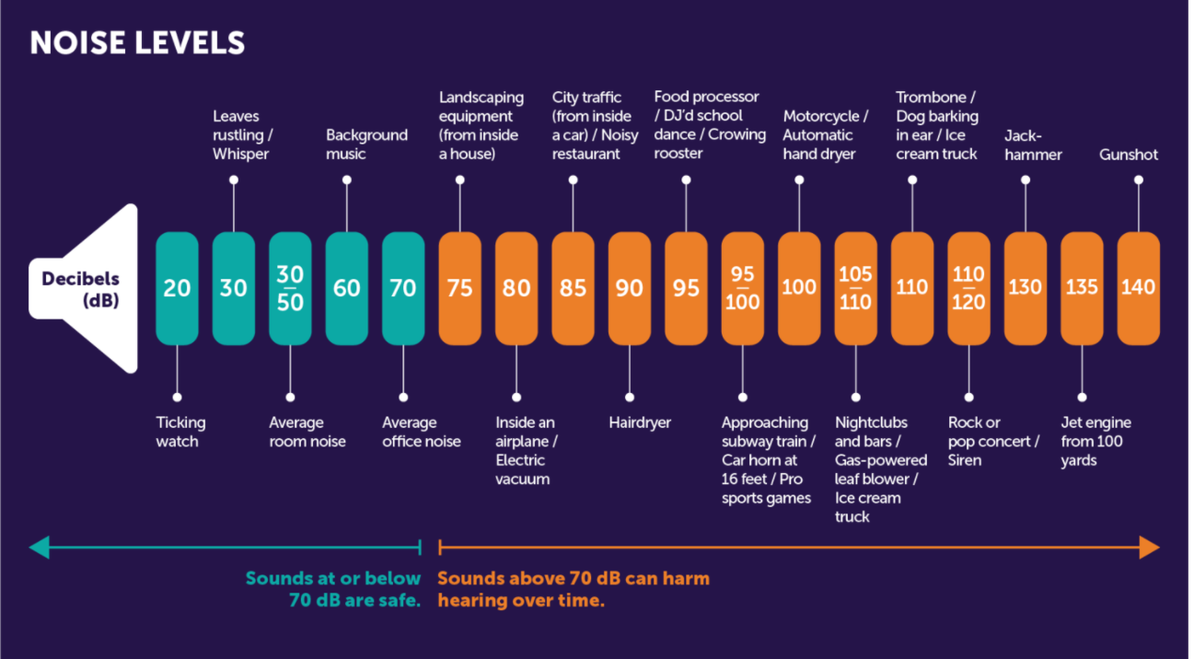

Figure 5. Recommended sound decibels and possible sound sources at specified decibel amounts

Lithium Polymer batteries are considered safe for consumer use; however, it is imperative that the user follow some recommended best practices. Li-Po batteries should not be stored below 32°F or above 122°F, or kept near flammable or combustible materials. The contents of Li-Po batteries are harmful, and the batteries should not be punctured or bent in any way. The device must always be powered off while charging.

# Technical Background

**OverEar Algorithm**

The algorithm functions by sampling audio from left and right microphones at a rate of 44.1 kHz. This high fidelity industry standard of sampling is enabled due to the Teensy 3.X shield. The data will then pass through a low-frequency filter to filter out the ambient noise of low frequencies. Once this preprocessing has occurred, the signals are minimized. This magnitude minimization is demonstrated in Figures 6 and 7 with Figure 6 featuring the right and left signals superimposed and Figure 7 as the minimum of the combined amplitudes.

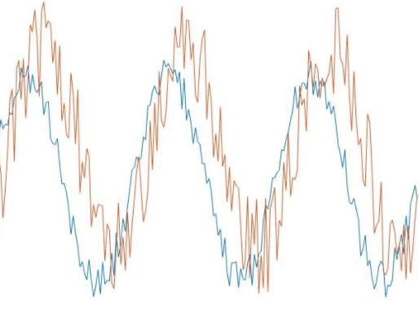

Figure 6. Two dummy signals (two out of phase sine signals with gaussian noise) represent audio from left and right microphones.

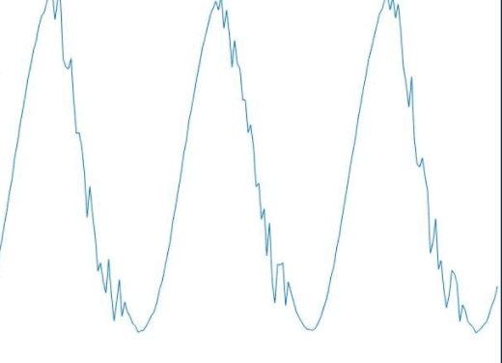   
Figure 7. The minimum of the two simulated sinusoidal signals

After the signals are minimized, the left and right microphone data pass through a queue which serves as an input to a cross-correlation function. The cross-correlation returns a value -1 to 1 indicating the relatedness of the two signals. If the signals are strongly related, the absolute value of the cross-correlation is close to one. The physics of sound allows for the left and right signals to be most similar when the orientation is in front of the user (which is the 0th azimuth). The signals’ amplitudes are multiplied by the cross-correlation coefficient squared (in order to make values closer to 1 more dominant).

Once the signal has gone through the cross-correlation filter, the signal is then output as a single sound through a mono-channel to the user’s earbuds.

**Battery Specification**

Measurement of the Overear device produced an average electrical usage of 65 milliamps at 3.7 volts, for a total power consumption of 242 milliwatts. Accordingly, we settled on a 1800 mAh Lithium-Polymer battery, which connects to the device using terminal screws.

# Relevant Engineering Standards

**Underwriters Laboratories (UL) Battery Safety Standards**

Our end device makes use of a Lithium-Polymer battery. Thus, we must ensure that it, along with our device, meets the standards imposed by UL. We have decided that the OverEar device should only use UL-certified batteries even though such a designation is not strictly mandatory in the U.S. because our device may be categorized as medical (most hearing-aid type devices are) by the FDA, which has 2 UL Battery Safety Standards.

# Cost Breakdown

| Project Costs for Production of Beta Version (Next Unit after Prototype) | | | | |
| --- | --- | --- | --- | --- |
| Item | Quantity | Description | Unit Cost ($) | Extended Cost ($) |
| 1. Teensy 3.5 | 1 | Development board/Microcontroller | 36.73 | 36.73 |
| 2. Teensy Audio Shield | 1 | Audio adaptor | 17.00 | 17.00 |
| 3. Microphone | 2 | MAX4466 with Adjustable Gain | 2.00 | 4.00 |
| 4. Battery | 1 | 1800 mAh, Li-Po | 8.99 | 8.99 |
| 5. 3D prints | 1 | Casing for device components | 3.00 | 3.00 |
| 6. Mute Pushbutton | 1 | Microcenter Pushbutton Switch | 2.00 | 2.00 |
| 7. Volume Knob | 1 | Rotary Encoder | 4.00 | 4.00 |
| 8. On/Off Switch | 1 | Unbranded Switch | 2.00 | 2.00 |
| 9. PCB | 1 | Custom PCB that connects all electronics | 1.50 | 1.50 |
| 10. Misc | 1 | Wires, terminals, etc. | 1.00 | 1.00 |
| Beta Version-Total Cost | | | | 80.22 |

The main expense of the OverEar device is the Teensy microcontroller because it is the main component of the device, and it is where the sound segregation algorithm will run concurrently with all the necessary processing.

For the alpha version, there is the cost of earbuds or headphones, but in the beta, the user can use any audio output device as long as it has a male audio jack.

For the software used, it is the Arduino IDE + Teensyduino which is where the programming is done, and it is free to use. In other words, it did not add any cost to the project.

# Appendices

## Appendix A - Specifications

| Specification | Quantity |
| --- | --- |
| Battery Life | ~ 18 hours |
| Weight | 205 grams |
| Range of Operation | 20° from in front of user |
| Size | 25 x 98 x 60 mm |
| Processing Delay | Negligible |
| Cost | < $100 |

## Appendix B – Attenuation Characteristics

The following graph shows the attenuation of a constant tone across from -90° to 90° degrees. The central angle (0° degrees) attenuates the least and amplitude decreases as the angle between the source and the user increases.

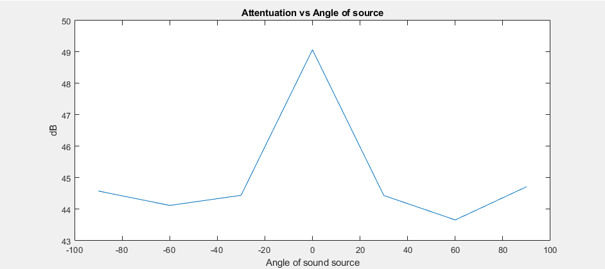

## Appendix C – Team Information

Our team consists of the following four students:

Guillermo Ao is a graduating Electrical Engineering student at Boston University. He worked on the product design of OverEar and the I/O hardware interface. After graduation, he is pursuing an MS in Robotics at Boston University.

Hannah Gold is a graduating Electrical Engineer at Boston University. She enjoys drawing portraits, cooking, swimming, and reading about innovations in STEM. She is pursuing her Electrical Engineering Ph.D. at MIT starting in the Fall of 2022 to do research in nanophotonics.

Benjamin Li is a graduating Computer and Electrical Engineering student at Boston University. He developed the sound-segregation algorithm for OverEar. Benjamin runs the High Performance Computing club on campus and has an interest in computer algorithms and oyster farming. After graduation, he will adopt a golden retriever.

Jonathan Ngo is a graduating Electrical Engineering student at Boston University. He often finds himself pursuing his interests such as going on walks, cooking, and solving logic puzzles. After graduation, he will leverage the valuable experience gained throughout the past few years at Raytheon Intelligence & Space.